**CHAPTER FOURTEEN**

**CYLINDERS AND CONES**

**The cylinder:**

h

r

* The above figure is known as a cylinder.
* The height of this cylinder is h and its radius is r.
* The shaded portion is called the total surface area of the cylinder, also referred to as the area of the cylinder.
* The area of a cylinder is made up of three parts and these are:

1. The top circular flat surface area, which is also referred to as the top surface area, and which is indicated in the next diagram, by means of shading:

* The flat top circular surface area $=πr^{2},$ since it is circular in shape where r = the radius.

1. The curved surface area, which is indicated by means of shading, in the next figure:

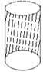

* The curved surface area = 2 $π$ rh, where h = the height.

The bottom circular surface area, which is indicated in the next diagram by means of shading:

* The bottom surface area = $=πr^{2},$ since it is also circular in shape.

**The area of a cylinder:**

The total surface area of a cylinder is therefore had by adding together all these three surface areas,

i.e

+ = + = + =

.

Q1. The height of a cylinder is 5cm and its radius is 2cm. Calculate

1. its flat top circular area.

b) its flat bottom circular area.

c) its curved surface area.

d)its total surface area. [Take $π=3.14$].

Soln.

h = 5cm, r = 2cm and $π=3.14.$

1. The flat top surface area = $πr^{2}=3.14×2^{2}=3.14×4=12.56cm^{2}$
2. The flat bottom surface area = $πr^{2}=3.14×2^{2}=3.14×4=12.56cm^{2}$
3. The curved surface area = 2 $πrh=2×3.14×2×5=62.8cm^{2}$
4. The total surface area = top surface area + bottom surface area + curved surface area = 12.56c $m^{2}+12.56cm^{2}+62.8cm^{2}=87.9{cm}^{2}$.

N/B: Also the total surface area = 2 = 87.9cm2.

Q2. A cylinder has a height of 40m and a diameter of 12m. Determine

1. its bottom circular area .
2. its curved surface area.
3. Its total surface area.

[Take $π=3.142]$

Soln:

Since d =12m $⟹r=\frac{12}{2}=6m.$

Also $π=3.142 and h=40m.$

1. The bottom circular surface area = $πr^{2}=3.142×6^{2}=3.142×36=113m^{2}$
2. The curved surface area = 2 $πrh=2×3.142×6×40=1508m^{2}$
3. The total surface area = 2m2.

Q3. A water storage tank is to be constructed using aluminum. If it is to have a diameter of 40m and a height of 120m, determine the amount of aluminum that will be needed to construct

1. its curved surface area .
2. the whole tank. [ Take $π or pie=3.14$].

Soln.

Since d = 40m $⟹r=\frac{40}{2}=20m.$ Also pie = 3.14 and h = 120m.

1. The amount of aluminum which is needed to construct the curved surface area = the curved surface area = 2 $πrh=2×3.14×20×120=15072m^{2}$
2. The amount of aluminum needed to construct the whole tank = the total surface area = 2 $πr\left(r+h\right)=2×3.14×20\left(20+120\right)$

$$=126\left(140\right)=17640m^{2}$$

Q4.

0.12m

8cm

The given figure is that of a drinking cup, which is to be constructed using plastic. If it is to be 0.12m long and have a diameter of 8cm, determine the quantity of plastic needed for its construction. [Take $π=3.142$].

N/B:

* A drinking cup has no top surface area $⟹plastic$ will only be needed to construct the curved surface area and the bottom surface area.
* Also since the height is given in metres and the diameter in centimetres, the metres must be converted into centimetres.

Soln.

h = 0.12m = 0.12 x 100 = 12cm.

D = 8cm $⟹r=4cm.$

The amount of plastic needed to construct the curve surface area $=2πrh=2×3.142×4×12=302cm^{2}$.

The amount of plastic needed to construct the bottom surface area = bottom surface area = $πr^{2}=3.142×4^{2}=3.142×16=50cm^{2}$.

The quantity of plastic needed to construct the cup = amount of plastic needed to construct the curved portion + the amount of plastic needed to construct the bottom surface = 302 + 50 = 352 ${cm}^{2}$.

Q5. The curved surface area of a cylinder of height 80cm is 2880 ${cm}^{2}.$ Calculate

1. Its total surface area .
2. Its circular top surface area. [Take $π=3.14$]

Soln.

The curved surface area = 2 $πrh,$ and since the curved surface area of the cylinder is given as 2880 ${cm}^{2}⟹2πrh=2880,⟹2×3.14×r×80=2880,$

$$⟹502r=2880,⟹r=\frac{2880}{502}⟹r=5.7cm.$$

1. The total surface area $=2πr\left(r+h\right)=2×3.14×5.7\left(5.7+80\right)=36\left(85.7\right)=3085cm^{2}$
2. The top circular surface area = $πr^{2}=3.14×5.7^{2}=102cm^{2}$.

N/B: Since in the question the heights as well as the curved surface areas were given, we must first determine the radius.

* In the next question, the curved surface area is given as well as the radius. We must therefore first determine the height.

Q6. The curved surface area of a cylinder whose radius is 5cm is 628 $cm^{2}.$ Determine its total surface area.

Soln.

r = 5cm and h = ?

Since the curved surface area = 628 ${cm}^{2},$ then 2 $πrh=628⟹2×3.14×5×h=628,⟹31.4h=628⟹h=\frac{628}{3.14}=20.$

Total surface area = 2 $πr\left(r+h\right)=2×3.14×5\left(5+20\right)=31.4\left(25\right)=785cm^{2}$

Q7. A cylinder has a top surface area of 12.56cm2 and a height of 0.8m. Calculate

1. its curved surface area.
2. its total surface area.

[Take $π=3.142]$

Soln.

Top surface area = 12.56cm2, h = 0.8m = 0.8m x 100 = 80cm.

$$π=3.142 and r=?$$

The top surface area is given by $πr^{2}$, and since this = 12.56cm2, then

.

Since $r^{2}=4⇒r=\sqrt{4}=2.$

1. Curved surface area = $2πrh=2×3.142×2×80=1005{cm}^{2}$
2. The total surface area = 2 $πr\left(r+h\right)=2×3.142×2\left(2+80\right)=12.56\left(82\right)=1030{cm}^{2}.$

**The volume of cylinder:**

* The volume of a cylinder is the amount of gas, liquid or solid which it can contain or hold.
* The volume of a cylinder is given by $v=πr^{2}h,$ where r = the radius and h = the height.

Q1. A cylinder has a height of 80cm and a diameter of 20cm. Calculate

1. its volume
2. the volume of air it will contain when it is
3. full ii. half full.

[Take $π=3.143]$

Soln.

d = 20cm $⇒r=10cm$.

1. Volume = $πr^{2}h=3.14×{10}^{2}×80=25120{cm}^{3}$.
2. i. The volume of air it will contain when it is full = 25120 ${cm}^{3}$.

ii. The volume of air it will contain when it is half full $=\frac{1}{2}×25120=12560{cm}^{2}$.

Q2. A cylinder is to be constructed in order to have a volume of 5540cm3. If it is to have a radius is 20cm, calculate its height.

Soln.

$$v=5540{cm}^{3},r=20cm and h=?$$

Since $v=πr^{2}h,$ then 5540 = 3.14 $×{20}^{2}×h,⇒5540=1256h⇒h=\frac{5540}{1256}=4.4$,

$∴$ the height = 4.4cm

Q3. A cylindrically shaped water tank, can hold 7000cm3 of water when it is full. If it has a height of 50cm, determine its radius.

Soln.

$$v=7000{cm}^{3},h=50cm and r=?$$

Since $v=πr^{2}h,$ then 7000 = $3.14×r^{2}×50,⇒7000=157r^{2},⇒r^{2}=\frac{7000}{157},⇒r^{2}=44.5,⇒r=\sqrt{44.5}=>r=6.6cm$

Q4. Water for sale is stored in a cylindrically shaped tank, of height 120m and diameter 40m. If the tank is full and a bucket whose volume id 200m3, is used to sell the water at a price of ¢2 per bucket, calculate the total amount expected if all the water was sold. [Take $π=3.142$]

Soln.

D = 40m $⇒r=20m.$

Also h = $120m and π=3.142$

The amount of water the tank will contain when full = the volume of the tank = $πr^{2}h=3.142×{20}^{2}×120=3.142×400×120=150816m^{3}$.

The volume of the bucket used in selling the water = 200m3the number of buckets of water which can be had from the tank $=\frac{150816}{200}=754$ buckets.

Since the price of water per bucket = ¢2, then the total amount had = 754 x 2 = ¢1508.

Q5. The total surface area of a closed circular cylinder of radius 3.5cm is 1320cm2. Calculate the volume of the cylinder.

Soln

Area of the cylinder = 1320cm2.

Radius = r = 3.5cm

Height = h = ?

We must first find the height

Area of cylinder = $2πr(r+h)$.

Since the area of the given cylinder = 1320cm2, then ,,

.

Volume of cylinder = $πr^{2}h=3.14×3.5^{2}×56.5=2173cm^{3}$.

Q6. The volume of a cylinder is 126cm3. If its height is 10cm, calculate

1. Its total surface area.
2. its curved surface area.

[Take $π=3.14$]

Soln.

Volume of cylinder = $πr^{2}h$

Since the volume is given as 126cm3, then

If $r^{2}=4⟹r=\sqrt{4}=2$ cm.

1. Total surface area

= 2 $πr\left(r+h\right)=2×3.14×2(2+10)$

= 12.6(12) = 12.6 x 12 = 151cm2.

(b) Curved surface area

= 2 $πr$ h = 2 x 3.14 x 2 x 10

= 126cm2.

Q7. The curved surface area of a cylinder whose diameter is 8cm is 1507cm2. Determine the volume of water it can contain, when it is filled with water.

N/B: First determine the height.

Soln.

The curved surface area is given by $2πrh and r=\frac{8}{2}=4cm$

But since the curved surface area = 1507, then 2πrh = 1507,

$⟹2×3.14×4×h=1507,⟹25.12h=1507⟹h=\frac{1507}{25.12}⟹h=60cm$.

Volume of cylinder = the volume of water the cylinder will contain = $πr^{2}h=3.14×4^{2}×60=3.14×16×60=3014cm^{3}$

N/B: The volume of a cylinder is also given by V = either the top or bottom circular surface area x h, where

V = volume and h = height.

Q1. A cylinder has a top circular surface area of 240cm2. If it has a height of 80cm, calculate its volume.

Soln.

h = 80cm, V =?

V = circular surface area x height

V = 240 x 80 = 19200cm3

Q2. The amount of water which a cylinder can contain is 5100cm3. If it has a circular surface area of 340cm2, determine its height. [Take ]

Soln.

V = 5100cm3, circular surface area = 340cm2,

V = circular surface area x height, $⟹$ v = 340 x h => 5100 = 340h => h = $\frac{5100}{340}=15$.

=> The height = 15cm.

Q3. The volume of a cylinder is 126cm3. If its height is 10cm, calculate

Soln.

1. its curved surface area
2. its total surface area

Soln.

Volume of cylinder = $πr^{2}h.$

Since the volume is given as 126cm3, then

cm.

1. Curved surface area = $2πrh=2×3.14×2×10=126cm^{2}$.
2. Total surface area = $2πr\left(r+h\right)=2×3.14×2\left(2+10\right)=12.6×12=151cm^{2}$.

**Spheres:**

* The volume of a sphere = $\frac{4}{3}πr^{3}$.
* The area of a sphere = 4π $r^{2}$.

(Q1) The diameter of a sphere is 12cm. Calculate

1. its volume
2. its area

Soln.

D = 12cm r = 6cm.

Volume = $\frac{4}{3}πr^{3}$ = $\frac{4}{3}×3.14×6^{3}$

= $\frac{4}{3}×3.14×$ 216 = $\frac{2712.96}{3}$

= 904 ${cm}^{3}$.

1. The area = $4πr^{2}$

= $4×3.14×6^{2}$ = $4×3.14×$ 36

= 452 ${cm}^{2}.$

(Q2) A water tank is spherical in shape and has a radius of 10m. Calculate

1. the volume of water it will contain when it is full
2. the amount of zinc needed to construct the tank.

Soln.

(a) Volume of water it will contain when full = the volume of the sphere = $\frac{4}{3}πr^{3}$ =

$\frac{4}{3}×3.14×{10}^{3}$ = $\frac{12560}{3}$ = 4187 $m^{3}$.

$\left(b\right)$ The amount of zinc needed to construct the sphere,

=> the area of the sphere = 4π $r^{2}$ = $4×3.14×{10}^{2}$

= 1256 $m^{2}$.

N/B: - A hemisphere is a half sphere.

* The volume as well as the area of a hemisphere is half that of a sphere.
* Since the area of a sphere = 4π $r^{2}$, then the area of a hemisphere = $\frac{1}{2}×4πr^{2}$ = 2π $r^{2}$.
* Also since the volume of a sphere = $\frac{4}{3}πr^{3}$, then the volume of a hemisphere = $\frac{1}{2}×\frac{4}{3}πr^{3}$ = $\frac{4}{6}πr^{3}$ = $\frac{2}{3}πr^{3}$

(Q3) A hemisphere has a radius of 12cm. Calculate

1. its area.
2. its volume.

Soln.

1. The area of a hemisphere = $2πr^{2}$

= $2×3.14×{12}^{2}$ = $2×3.14×$ 144 = 904 ${cm}^{2}.$

(b)The volume of a hemisphere = $\frac{2}{3}πr^{3}$

= $\frac{2}{3}×3.14×{12}^{3}$ = 3617 ${cm}^{3}$.

(Q4)

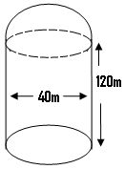

The above shows a petrol tank which is to be constructed. It is to be in the form of a cylinder of height 120m and diameter 40m. The top part of the tank is to be in the form of a hemisphere. Calculate

1. the volume of air it will contain.
2. The amount of aluminum which will be needed to construct it.
3. the cost of building the tank, given that ${2cm}^{2}$ of aluminum cost ¢2.

Soln.

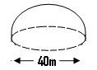

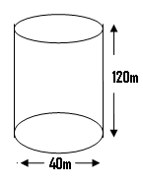

The volume of the given figure = the volume of the air it can contain.

Therefore the volume of the figure = volume of hemisphere + the volume of the cylinder.

Soln.

radius of hemisphere = 20m.

volume of hemisphere = $\frac{2}{3}πr^{3}$

= $\frac{2}{3}×3.14×{20}^{3}$.

= 16747 $m^{3}$

For the cylinder, r is also = 20m.

The volume of the cylinder = $πr^{2}h$

= $3.14×{20}^{2}×$ 120

= 150720 $m^{3}$.

Volume of air the structure can contain = the volume of the hemisphere + the volume of the cylinder

= 16747 + 150720 = 167467 $m^{3}$

1. The amount of aluminum needed to construct it is equal to the area of the hemisphere + the area of the curved surface + the area of the bottom surface.

i.e

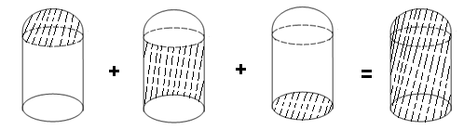

(a)(1) The area of the hemisphere = $2πr^{2}$

= $2×3.14×{20}^{2}$ = $2×3.14×400$

= 2512 $m^{2}$

(2) The area of the curved surface of the cylinder

= $2πrh$ = $2×3.14×20×120$

= 15072 $m^{2}$

(3) The bottom circular surface area = π $r^{2}$

= $3.14×20^{2}$ = $3.14×$ 400 = 1256 $m^{2}$

∴ Amount of aluminum needed

= 2512 + 15072 + 1256

= 18840 $m^{2}$.

**Cones**

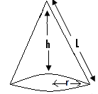

* The given figure is that of a cone, whose height is h.
* The length indicated by l is referred to as the slanted height of the cone, with r being the radius of the cone.
* Half of the given figure drawn can be represented as shown next:

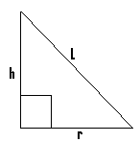

From Pythagoras theorem, $l^{2}=h^{2}+r^{2}$

$l= \sqrt{h^{2}+r^{2}}$.

(Q1) A cone has a radius of 3cm and a height of 4cm. Determine its slanted height.

Soln.

r = 3cm and h = 4cm.

$l=\sqrt{h^{2}+r^{2}}$, where $l$ = slanted height,

$l$ = $\sqrt{4^{2}+3^{2}}$ = $\sqrt{16+9}$,

$l$ = $\sqrt{25}$ = 5cm.

(Q2) A cone has a slanted height of 11.2 cm and a radius of 5cm. Find its height.

Soln.

From $l^{2}=h^{2}+r^{2}{ l}^{2}-r^{2}$ = $h^{2}$,

$h^{2}$ = $l^{2}-r^{2}$, h = $\sqrt{l^{2}-r^{2}}$,

h = $\sqrt{11.2^{2}-5^{2}}$, h = $\sqrt{100}$ = 10cm.

**Total surface area of a cone:**

* The total surface area of a cone depends on whether it is a solid or a hollow cone.

*A hollow cone is a cone without a base and a solid one is one which has a base.

$$Total surface area of a hollow cone:$$

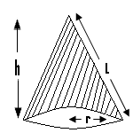

* A hollow cone consists only of the curved surface area, which has been shaded in the given diagram.
* The total surface area of such a cone is given by πr $l$, where l $= \sqrt{h^{2}+r^{2}}$.

$The$ total surface area of a solid cone $:$ 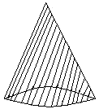

* This figure is that of a solid cone, and the shaded portion is what is referred to as its total surface area, which consists of two parts.

1. The curved surface area which is shaded in the next figure

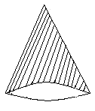

* The curved surface area is given by πr $l$, where

$l$ = $\sqrt{h^{2}+r^{2}}$.

1. The base circular surface area, which has been shaded in the next figure:

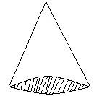

* The base circular surface area is given by π $r^{2}$,

where r = the radius of the cone.

* The total surface area of a solid cone is given by

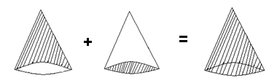

Πr $l$ + π $r^{2}$ = Πr ( $l+r)$.

(Q1) A cone has a slanted height of 12cm and a radius of 6cm. If it is a hollow cone, calculate its total surface area.

[Take π = 3.142]

Soln.

$l$ = 12cm and r = 6cm.

Total surface area = Πr $l$

= 3.14 $×6×12=226{cm}^{2}$

(Q2) A hollow cone has a height of 4cm and a radius of 3cm. Calculate its total surface area. [Take π = 3.142]

N/B: Since the slanted height is not given, we first have to find it.

Soln.

h = 4cm, r = 3cm and $l$ = ?. Since $l$ = $\sqrt{h^{2}+r^{2}}$

$l$ = $\sqrt{4^{2}+3^{2}}$ = $\sqrt{16+9}= \sqrt{25}$,

$l$ = $\sqrt{25}l$ = 5.

Surface area of a hollow cone = Πr $l$ = 3.14 $×$ 3 x 5

= 47 ${cm}^{2}$

(Q3) A hollow cone is to be constructed using zinc. If it is to have a diameter of 4cm and a height of 6cm, determine the quantity of zinc which will be needed.

Soln.

d = 4cm r = 2cm, h = 6cm and $l$ = ?. But $l$ = $\sqrt{2^{2}+6^{2}}$

= $\sqrt{4+36}$, $l$ = $\sqrt{40}$ = 6.3cm.

The amount of zinc needed = the surface area = π $rl$

= 3.14 $×2×6.3$ = 39.6c $m^{2}$.

(Q4) The total surface area of a hollow cone of diameter 6cm, is 47 ${cm}^{2}$. Calculate

1. Its slanted height.
2. its height.

[Take π = 3.14].

Soln.

(a) d = 6cm r = 3cm and total surface area = 47cm2

Since the total surface area = πr $l$, then πr $l$ = 47.

3.14 $×3×l$ = 47, 47 = 9.42 $l$, $l$ = $\frac{47}{9.42}$ = 5,

slanted length = 5cm.

(b) $l$ = 5cm, r = 3cm and h =?. From $l^{2}=h^{2}+r^{2}$

$h^{2}$ = $l^{2}$- $r^{2}$, h = $\sqrt{l^{2}- r^{2}}$ = $\sqrt{5^{2}- 3^{2}}$,

h = $\sqrt{25-9}$ = $\sqrt{16}$ = 4cm.

N/B: When the term cone is used without any adjective qualifying it (i.e. solid or hollow), then the assumption is that, it is a solid cone.

(Q5) A solid cone is to be constructed to have a radius of 6cm, and a slanted height of 10cm. Determine

a) its curved surface area.

$\left(b\right)$ its base circular surface area.

1. its total surface area.

Soln.

$r=6cm and l=10cm$.

$(a)$ curved surface area = π $rl$

$=$ 3.14 $×6×10$ = 188.4 $cm^{2}$

$(b)$ The base circular surface area = π $r^{2}$ = 3.14 $×6^{2}=113cm^{2}$

(c) The total surface area = curved surface + base circular surface area = 188.4 + 113 = 301.4 $cm^{2}$

(Q6) A cone has a radius of 6mm and a height of 8mm. Determine

1. its curved surface area.
2. its total surface area.

[Take π = 3.14]

Soln.

r = 6mm and height = 8mm. But $l$ = $\sqrt{r^{2}+h^{2}}$

= $\sqrt{6^{2}+8^{2}}$ = $\sqrt{36+64}$ = $\sqrt{100}$ = 10m.

(a) The curved surface area = π $rl$ = 3.14 $×6×10$

$$=188.4{cm}^{2}$$

(b) The total surface area = πr(r + $l$)

= 3.14 $×6(6+10)$ = 18.8(16) = 300 ${cm}^{2}$.

Method 2

The base circular surface area = ${πr}^{2}$

= 3.14 $×6^{2}=3.14×36$ = 113 ${cm}^{2}$

The total surface area = the curved surface area + the base surface area = 188.4 + 113 = 301 ${cm}^{2}$

(Q7) A cone whose diameter is 8m, has a curved surface area of 503 $m^{2}.$ Determine

1. its slanted height.
2. its total surface area.

Soln.

d = 8m $r=4m$.

Curved surface area = πr $l$. But since curved surface area = 503m2,

πr = 503, 3.14 $×4×l=503,$

12.56 $l$ = 503 $,l$ = $\frac{503}{12.56}$

$l$ = 40m

(b) Total surface area = πr( r + $l$)

= 3.14 $×4\left(4+40\right)=12.56(44)$

= 553 $m^{2}$.

(Q8)

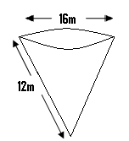

Above shows a structure in the form of a solid cone which is to be painted.

a) Determine its total surface area.

b) If an area of 20 $m^{2}$ requires 3 gallons of paint, determine the number of gallons needed to paint the whole structure. [Take π = 3.14

Soln.

(a) d = 16m r = 8m, $l$ = 12m and h = ?

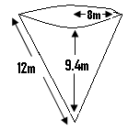

From - = ,

- h = $\sqrt{l^{2}-r^{2}}$,

h = $\sqrt{{12}^{2}-8^{2}}=\sqrt{144-64}$ = $\sqrt{80}$,

h = 9.4m

Total surface area = πr( r + $l$)

= 3.14 $×$ 8( 8 + 12 ) = 502 $m^{2}$.

(b) ${20m}^{2}$ = 3 gallons

502 $m^{2}$ = $\frac{502}{20}×3$ = 75 gallons.

(Q9)

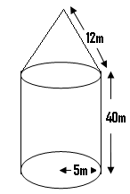

The given structure is to be constructed using copper. Its lower portion takes the form of a cylinder of height 40m and radius 5m. The upper portion takes the form of a cone (i.e. hollow cone) whose slanted height is 12m.

a) Find the height of the cone.

b)Determine the total area of this structure.

c) If 50 $m^{2}$ of copper cost ¢2, what will be the amount needed to construct the structure.

[Take π = 3.14]

N/B: Separate the structure into two portions i.e. the upper and the lower portion and determine the area of each separately.

Soln.

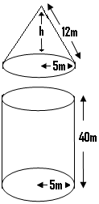

N/B: The cone and the cylinder will have the same radius or diameter.

a) (i) Considering the cone:

$l$ = 12m, r = 5m and h = ?

From - = ,

- h = $\sqrt{l^{2}-r^{2}}$

= $\sqrt{{12}^{2}-5^{5}} ,$ h = $\sqrt{144-25}= \sqrt{119}$

h = 11m.

(b) The total area of the cone (which is a hollow one)

= πrl = 3.14 $×5×12=188m^{2}$

(2) Considering the cylinder:

The total area in this case = the curved surface area + the bottom circular surface area.

The curved surface area of the cylinder = 2πrh

= $2×3.14×5×40=1256m^{2}$

The bottom circular surface area = π $r^{2}$

= 3.14 $×5^{2}=3.14×25=79m^{2}$

The total area of the given structure = the area of the cone + the curved surface area of the cylinder + the area of the circular base of the cylinder, $total surface area=188+1256+79=2952m^{2}$

$Therefore$ the amount of copper needed = $2952m^{2}$.

c) If 50 $m^{2}$ = ¢2

$2952m^{2}$ = $\frac{2952}{50}×2$

= ¢188.

(Q10) The lower portion of a building is cylindrical in shape, and has a height of 5.2m. Its roof takes the form of a cone whose diameter is 7m with a height of 4m. Determine

1. the slanted height of the roof.
2. the area of the roof.
3. the total area of the building.

[Take π = 3.14 and assume that the base of the building forms part of it].

Soln.

Since d = 7m r = 3.5m.

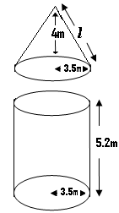

(a) h = 4m , r = 3.5m and $l$ = ? .

From $l^{2}= h^{2}+r^{2 }l$ = $\sqrt{h^{2}+r^{2 }}$,

$l$ = $\sqrt{4^{2}+{3.5}^{2}} = \sqrt{16+12.3}$ = 5.3m,

the slanted height = 5.3m.

(b) The area of the roof = πrl

= 3.14 $×3.5×5.3$ = 58 $m^{2}$.

(c) The curved surface area of the cylinder = 2πrh

= $2×3.14×3.5×5.2=114m$

The bottom circular surface area of the cylinder = π $r^{2}$

= $3.14×3.5^{2}=3.14×12.25=38.5m^{2}$.

The total area of the building = area of the roof + area of the curved surface + area of the bottom surface = 58 + 114 + 38.5 = 210 $m^{2}$.

**The volume of cone:**

* The volume of a cone refers to the amount of solid, liquid or gas which it can contain.

*The volume of a cone is given by V = $\frac{1}{3}×base area×height ,$

$V = \frac{1}{3}×πr^{2}×h=\frac{1}{3}πr^{2}h$.

(Q1) A cone has a base radius of 15cm and a height of 25cm. Calculate its volume.

Soln.

r = 15cm and h = 25cm.

V = $\frac{1}{3}×πr^{2}h=\frac{1}{3}×3.14×{15}^{2}×25$,

$$V=\frac{1}{3}×3.14×225×25$$

$V=589{cm}^{3}.$

(Q2) A cone is to be constructed to have a volume of 54000 ${cm}^{3}.$ If it is to have a height of 0.4m, determine its diameter.

Soln.

V = 54000 ${cm}^{3}$

h = 0.4m = 0.4 $×100=40cm.$

Since V = $\frac{1}{3}πr^{2}h=\frac{1}{3}×3.14×r^{2}×40,$

$54000=\frac{1}{3}×3.14×r^{2}×40$, $54000= \frac{125.5r^{2}}{3} ,$

$54000=42r^{2} ,{ r}^{2}=\frac{54000}{42}$, $r^{2}=5400 r= \sqrt{5400}$,

$$r=77.5cm , d=2×77.5 d=155cm.$$

N/B: The volume of a cone is also given by

V = $\frac{1}{3}×base area×height$.

(Q3) A cone has a base area of 240 ${cm}^{2} and$ a height of 40cm. Find its volume.

Soln.

V = $\frac{1}{3}×base area×height$

= $\frac{1}{3}×240×40=3200cm^{3}.$

(Q4) A hollow cone has a slanted height of 5cm, a height of 4cm and a surface area of 47 ${cm}^{2}$. Determine its volume.

N/B: First determine the radius since V = $\frac{1}{3}{πr}^{2}h,$ and h is given.

Soln.

Surface area of a hollow cone = πrl.

Since surface area = 47 ${cm}^{2}$,

$then πrl=47,3.14×r×5=47$,

$15.7r=47 r=\frac{47}{15.7}=3$,

$$r=3m.$$

Volume = $\frac{1}{3}×{πr}^{2}×h$

= $\frac{1}{3}×3.14×3^{2}×4=38cm^{3}$.

(Q5)

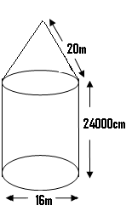

A building is to be constructed in the form of a cylinder which is 24000cm long and whose diameter is 16m. Its roof is to be in the form of a cone of slanted height 20m. Calculate the volume of air it will contain.

Soln.

d = 16m $r=8m, l=20m$.

The volume of the given structure = the volume of the cone + the volume of the cylinder.

Consider the cone:

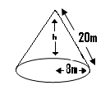

$$From {20}^{2}=h^{2}+8^{2},$$

$$400= h^{2}+64 400-64= h^{2},$$

$336= h^{2}h=\sqrt{336}$,

$$h=18m.$$

The volume of the cone

= $\frac{1}{3}πr^{2}h=\frac{1}{3}×3.14×8^{2}×18$

= $\frac{1}{3}×3.14×64×18$

= 1206 $m^{3}$

Consider the cylinder:

h = 24000cm = $\frac{24000}{100}=240m$

r = 8m.

V = πrh = $3.14×64×240=48230m^{3}$

The volume of the given structure = volume of the cone + the volume of the cylinder

= 1206 + 48230 = 49436 $m^{3}$

The amount of air the structure will contain = the volume of the given structure = 49436 $m^{3}.$

(Q6)

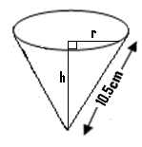

The diagram shows a cone with a slanted height of 10.5cm. If its curved surface area is 115.5 ${cm}^{2}, calculate$

1. the base radius, r.

(ii) the height h.

(iii) the volume.

Soln.

$l$ = 10.5cm and the curved surface area = 115.5 ${cm}^{2}$.

Since the curved surface area is given by πr $l$, then

πr $l$ = 115.5 3.14 $×r×10.5=115.5$, $33r=115.5, r= \frac{115.5}{33}$,

$r=3.5cm$.

Now for a cone, l2 – r2 = h2

,

=> 110.3 – 12.3 = ,

Volume of cone =

=

= 1275.

,

0.

b)The length of arc PQ = $\frac{θ}{360}×2πR$

= $\frac{169}{360}×2×3.14×17$

= 50cm.

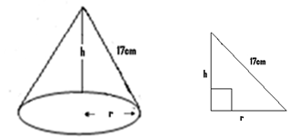

Since the length of the arc PQ = 2πr, then 2πr = 50,

$2×3.14×r=50 6.28r$ = 50, $r= \frac{50}{6.28}=9$.

Now from Pythagoras theorem, ${17}^{2}= r^{2}+h^{2}{17}^{2}=9^{2}+h^{2},{17}^{2}-9^{2}=h^{2}, h= \sqrt{{17}^{2}-9^{2}}$

=15cm.

(d) The volume = $\frac{1}{3}{πr}^{2}h= \frac{1}{3}×3.14×9^{2}×15=1003{cm}^{3}$

(Q7) Mr. Hansen took a circular copper plate of diameter 12m, and cut out from it a sector whose angle was 24 $0^{0}$. He then had this bent in order to form a cone. Determine

I) the radius of the circular base of the cone.

Ii) the height of the cone.

Iii) the vertical angle formed by the cone.

Iv) the amount of kerosene which the cone can contain.

(iv) the quantity of copper which was used to form this cone.[Take π = 3.14]

Soln.

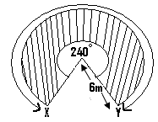

Since the diameter = 12m $the$ radius = 6m .

R = $l$ = 6m.

Also $θ$ = 24 $0^{0}$.

When the net of the cone shown is bent into a cone, the length of arc X Y will become the circumference of the cone formed.

$\frac{θ}{360}×2πR$ = $2πr$

i.e. length of arc = the circumference where r = the base radius of the cone.

$Therefore \frac{240^{0}}{360}×2×3.14×6$ =2 $×3.14×r$, $25=6.28r r= \frac{25}{6.28} r=4, the radius of the cone=4m.$

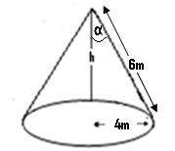

From this figure, r = 4m, $l$ = 6m and h = ?,

But since l2=,

1. Consider one half of the cone

i.e.

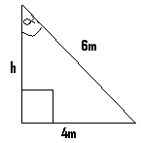

If ∝= the semi vertical angle, then sin ∝ = $\frac{4}{6}$,

$sin∝=0.66$,

$∝$ = $\sin^{-1}0.66 ∝=42^{0}$.

$The vertical angle=2×42={84}^{0}$.

1. The quantity of kerosene which the cone can hold = the volume = $\frac{1}{3}{πr}^{2}h$ = $\frac{1}{3}×3.14×4^{2}×4.5={75m}^{3}$.
2. The quantity of copper needed to form this cone = the total surface area = πr $l$ = 3.14 $×4×6={75m}^{2}$

**Summary of formulae:**

1. **Cylinder:**
2. Curved surface area = $2π$ rh.
3. Circular surface area = 2.
4. Total surface area = r(r + h).
5. Volume = r2h.
6. Volume = circular surface area x height. N/B:[ r = radius and h = height].
7. **Sphere**:
8. Surface area = 4r2.
9. Volume = r3.
10. **Hemisphere**:
11. Area = 2r2
12. Volume = r3
13. **Cone**:
14. Base circular surface area = 2.
15. Curved surface area = $π$ rl.
16. Surface area of a hollow cone = $πrl$
17. Surface area of a solid cone (cone) = $πr$ (r + l).
18. Volume = r2h
19. Also volume = $\frac{1}{3}$ x base area x height.

N/B:[ r = radius, h = height and $l$ = slanted height].

**e) Cuboid**:

(1) Volume = surface area x height

(2) Volume == L x B x H where L = length, B = breadth and H = height.

**(f)Cube**:

Area 2 and volume = 3, where = length or breadth or side.

N/B: (1) $\frac{r}{l}= \frac{θ}{360}$, where r = the radius of the cone formed, $and θ$ = the sector angle of the net used to form the cone.

(2)The sector area = x 2, where = sector angle and r = the radius of the circular plate or cardboard e.t.c.

(3)The length of a sector arc = $\frac{θ}{360}$ x 2πR, where $θ$ = the sector angle angle, and R = the radius of the circle or the circular sheet.

(4)The circumference of a cone = 2πr, where r = the base radius of the cone

**Questions:**

(Q1) A cylinder has a height of 8cm and a radius of 3cm. Find its

1. bottom circular surface area. Ans: 28. ${3cm}^{2}$
2. curved surface area. Ans: 151 ${cm}^{2}$
3. total surface area. Ans: 207 ${cm}^{2}$
4. volume. Ans: 226 ${cm}^{3}$

[Take π =3.142].

(Q2) A cylindrically shaped water tank is to be constructed using zinc. It is to be of height 40m, and and of diameter 16m. Determine the amount of zinc that will be needed to construct

1. the curved surface portion. Ans: 2010 $m^{2}$
2. the whole tank. Ans: 2412 $m^{2}$
3. Given that 5 $m^{2}$ of zinc cost ¢3, determine the total amount expected to be used to construct the whole tank. Ans: ¢1447.
4. What will be the amount of water the tank will contain when it is half full? Ans: 4019 $m^{3}$

[Take π=3.14]

(Q3) Given that the curved surface area of a cylinder whose radius is 6cm is 720 ${cm}^{2},$ find its

1. total surface area. Ans: 943c $m^{2}$
2. volume. Ans: 2149 ${cm}^{3}$

[Take $π=3.14]$.

(Q4) A cylinder is 60m long and contains 8400 $m^{3}$ of water when it is full. Determine

1. its radius. Ans: 6.7m
2. its diameter. Ans 13.4m

[Take π=3.142]

(Q5) A petrol storage tank, built in the form of a cylinder has a height of 0.91m and a top surface area of 16 ${cm}^{2}$. Calculate

1. its curved surface area. Ans: 1274 ${cm}^{2}$
2. its total surface area. Ans: 1306 ${cm}^{2}$
3. its volume. Ans: 1420 ${cm}^{3}$
4. If this tank is to be filled with petrol, which is pumped at a rate of 4 ${cm}^{3}$ per second, how long will it take to fill the tank. .[ Take π=3.14]. Ans 355 seconds.

(Q6) A gas cylinder of radius 18cm has a total surface area of 11480 ${cm}^{2}$. Determine the quantity of gas it will contain when it is fully filled.[ Take π =3.14]. Ans: 85458 ${cm}^{3}$.

(Q7) The area of one of the circular faces of a cylinder is 178 ${cm}^{2}$. If it is of height 120cm, determine its volume.

Ans: 21360 ${cm}^{3}$.

(Q8)

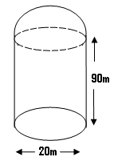

The above structure is to be constructed using aluminum. It consists of a cylinder of height 90m and diameter 20m, joined to a hemisphere as shown in the given diagram.

1. What will be the total surface area of the given structure? Ans: 6594 $m^{2}$
2. Determine the total volume of air which the structure will contain. Ans: 30353 $m^{3}$

[Take π = 3.14].

(Q9) A cone has a diameter of 8cm and a height of 12cm. Determine its slanted height. Ans: 12.6cm

(Q10) Determine the radius of a cone whose slanted height is 9cm, and whose height is 6cm. [Take π 3.14]. Ans: 6.7cm

(Q11) Find the total surface area of a hollow cone, whose height is 8cm, if it has a radius of 5cm. Ans: 148 ${cm}^{2}$

(Q12) The total surface area of a hollow cone of radius 6cm is 264 ${cm}^{2}$. Determine

1. its slanted height. Ans : 14cm
2. its height. Ans: 12.6cm

(Q13) Determine the total surface area of a solid cone whose slanted height is 12m, if it has a diameter of 16m. Ans: 502m2

(Q14) The curved surface area of a cone whose radius is 5cm is 620 ${cm}^{2}$. Find

1. its slanted height. Ans: 39cm
2. its total surface area. Ans: 699 ${cm}^{2}$

(Q15)

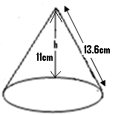

The given figure is that of a cone to be constructed. It is supposed to have a height of 11cm and a slanted height of 13.6cm. Determine

1. its curved surface area. Ans: 342 ${cm}^{2}.$
2. its total surface area. Ans: 543 ${cm}^{2}$.
3. its volume. Ans: 737 ${cm}^{3}$.

(Q16)

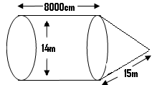

The structure shown is that of a fuel storage tank. It consists of a cylinder, which is attached to a hollow cone. The diameter of the cylinder is 14m and its length is 8000cm. If the cone has a slanted height of 15m, determine

1. the amount of aluminum which will be needed to construct this structure. Ans: 4000m2
2. the maximum volume of water the structure can hold. . Ans: 12991 $m^{3}$.

**CHAPTER FIFTEEN**

**CONSTRUCTION**

**Areas of some geometrical figures:**

**Rectangles:**

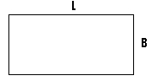

L = the length.

B = the breadth or width.

The area = L $×B$.

**Triangle:**

* This is a three sided figure.

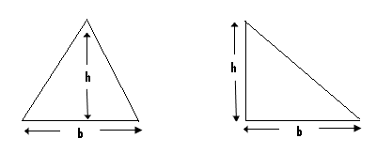

The area = $\frac{1}{2}$ b $×$ h = $\frac{b ×h}{2}$ where b = the base and h = the height.

**Parallelogram:**

* This is a four shaded figure, in which both pairs of its opposite sides are parallel.

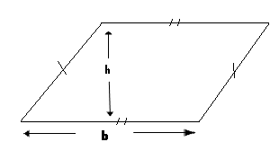

The area of a parallelogram = b $×$ h, where b = the base and h = the height.

**The trapezium:**

* This is a four sided figure, which has its pair of opposite sides being parallel.

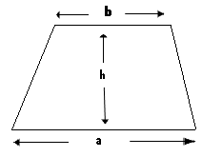

Area = $\left(\frac{a+b}{2}\right)×h,$ where h = the height and a and b are the parallel sides.

Angles:

* An angle is formed when two straight line meet at a point.

Example:

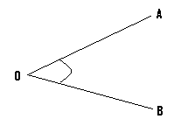

* In the above given figure, the lines OA and OB meet at the point O.
* The angle formed is angle AOB or angle BOA.
* Angle AOB can be written as <AOB or AOB , while angle BOA can be written as <BOA or BOA.

**BISECTION OF ANGLES:**

* To bisect a given angle means to divide it into two equal parts.

Examples(I):

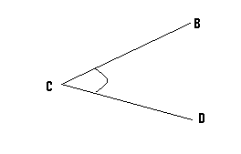

In the given figure, bisect <BCD.

Steps:

(I)

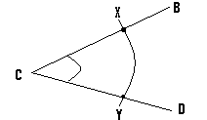

* Open your compass to a suitable length, and with its pin positioned at C, draw an arc to cut line CB at point X and line CD at point Y.

(II)

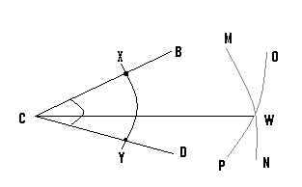

* Open your compass to a greater length and with its pin now positioned at point X, draw arc OP.
* With the same length and the pin now positioned at the point Y, draw arc MN and let the meeting point or the point of intersection of these two arcs be W.
* Finally draw a line to pass through the points C and W.
* By so doing, we have bisected <BCD.

**The bisector:**

* This may also be referred to as the perpendicular bisector.
* The bisector can be drawn to pass through a line, and by so doing, it will divide the line into two equal parts or lengths.
* On the other hand, a bisector can be drawn to pass through a given point.

**Construction of the bisector of a line:**

Example:



Line AB is of length 6cm. Construct the bisector of this line.

Steps:

(a)

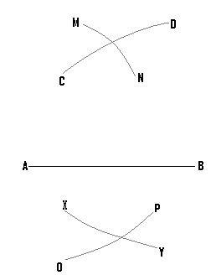

* Open your compass to a suitable length, and with its pin positioned at point B, draw arcs CD and XY.
* Using the same length and the pin now positioned at point A, draw arcs MN, and OP.

1. Finally draw a line to pass through the meeting points, or the points of intersection of the various arcs.

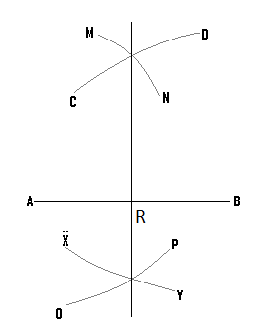

N/B: AR = RB.

**Bisector which passes through a given point:**

Example:



Construct the perpendicular bisector which passes through the point B.

Steps:

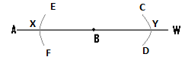

* Open your compass to a suitable length, and with the pin positioned at point B, draw arcs CD and EF.

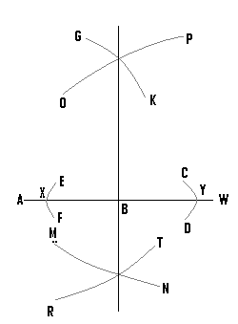

* Open the compass to a greater length, and with the pin positioned at point Y, draw arcs OP and MN.
* Using the same length and with the pin now positioned at point X, draw arcs GK and RT.
* Finally a line drawn to pass through the points of intersection of the various arcs, which is the bisector, will pass through the point B.

**Locus of points equidistant from two points:**

* Equidistance means equal distance.
* To construct the locus of points which are equidistant from two points, is to determine the various points which are of equal distance away, from these two points.

Examples:

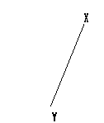

Construct the locus of all the points, which are equidistant from X and Y.

Steps:

(1)

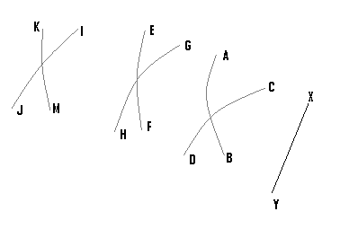

* Open your compass to an appropriate length, and with the pin positioned at the point X, draw arc AB.
* Using the same length and with the pin now positioned at the point Y, draw arc CD.
* Open your compass to a different or a greater length, and with the pin position at point X, draw arc EF.
* Using the same length and with the pin now positioned at the point Y, draw arc GH.
* Using a different length and the same procedure, we construct arcs JI and KM.

(2) Finally draw a line to pass through all the points of intersection, of all the arcs.

N/B: Locus is normally represented by a broken line.

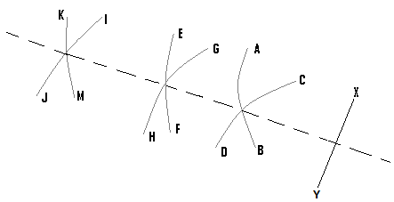

* The broken line is the locus of the points, which are equidistant from the points X and Y.
* Also any point on this line will be equidistant from X and Y.

**Locus of points equidistant from two lines:**

* In order to get such a locus, we bisect the angle between these two lines.

Examples:

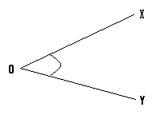

Construct the locus of the points, which are equidistant from the lines OX and OY.

Steps:

* Bisect <XOY.

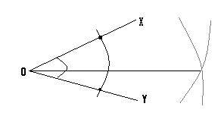

* The required locus is represented by the straight line, and any point on it will be at equal distance away from OX and OY.

Construction of angle 900:



With reference to line AB, construct angle 900 at the point X.

Steps:

(1)

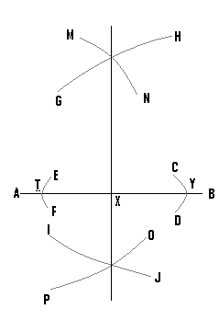

* Open your compass to a small length, and with the pin positioned at point X, draw arcs CD and EF.
* Open your compass to a greater length, and with the pin positioned at point Y, construct arcs GH and IJ.
* Using the same length and with the pin now at point T, draw arcs MN and OP.

1. Draw a line to pass through the point X, and the points of intersection of the various arcs.

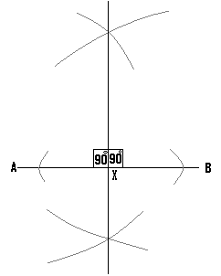

(Q1)(a) Using a ruler and a pair of compasses only, construct triangle ABC, such that <ABC = 900, BC = 7cm and AB = 5cm.

(b) Construct locus P1 of points which are 3cm away from B.

N/B:

* Ensure that the angle lies on the horizontal line, since this will make the work easy.
* It is also advisable to make a rough sketch of the diagram first.

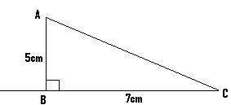

Soln:

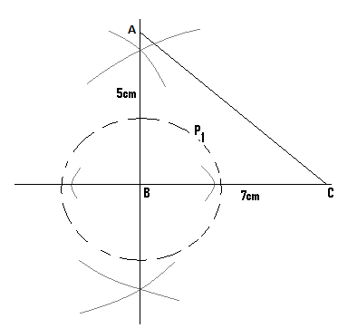

1. Open your compass to a length of 3cm, and with the pin positioned at the point B, construct locus P1 which is represented by the broken line.

**Construction of angle 450:**

* To construct angle 450 at a given point, we first construct angle 900 at that point.
* The angle 900 is then bisected to get angle 450.

Example:



Construct angle 450 at X.

Step(1)

* This involves the construction of angle 900 at the point X.

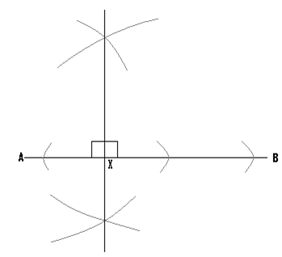

Step(2)

* Bisect the 900 to get 450.
* Since there are two angles of value 900, the one bisected depends on where we want the 450 angle to lie.

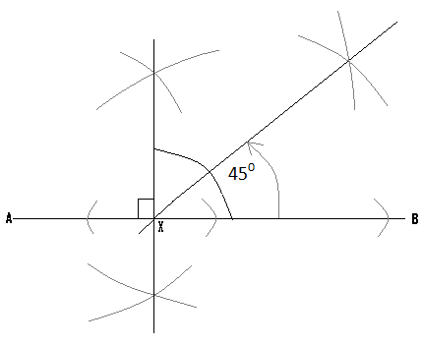

* Using an appropriate length and with the pin at point X, draw arc OP and open the compass to a greater length.
* Positioning the pin at point H and then at point J, draw arc EK and arc VW and let Y be their point of intersection.
* Finally from X, draw a line to pass through point Y.

(Q1)(a) Using ruler and compass only, construct MKF in which <MKF = 750, MFK = 600 and KF = 5CM.

1. Using K as centre draw a circle of radius 3cm.

Hint:

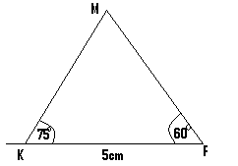

Soln:

N/B: - First construct angles 450 and the 600.

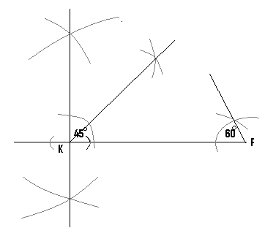

* In addition to angle 450, we construct angle 600 and bisect it to get angle 300.

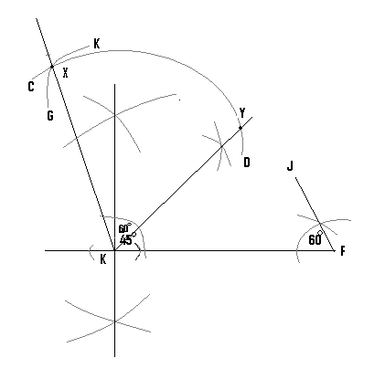

* Using a suitable length and with the pin positioned at K, draw arc CD.
* With the same length and the pin now positioned at point Y, draw arc GK and let X be the meeting point of these two arcs.
* From point K, draw a straight line to pass through the point X.
* The angle just constructed is angle 600.
* In the final stage, bisect the angle 600 to get angle 300.

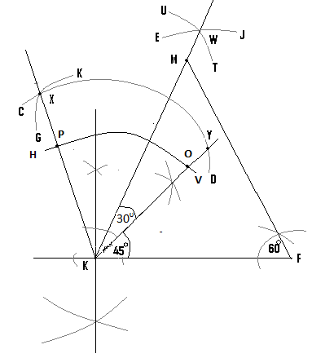

* Using a suitable length and from point K, draw arc HV.
* Using a greater length and from point P and O, draw arcs UT and EJ and let them meet at point W.
* Finally from K, draw a straight line to pass through W.
* Extend the line FJ to meet this straight line and let their meeting point will be point M.

N/B: It is only this final diagram which is necessary to be drawn.

(Q2)(a) Using ruler and a pair of compasses only, construct ABC in which AB = 6cm, BC = 5cm and <ABC = 750.

(b) Locate the point D, such that CD is parallel to AB and D is equidistant from A and .

(c) Construct the perpendicular line to meet AB at E.

(d) Measure CE .

Hint:

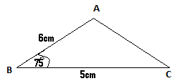

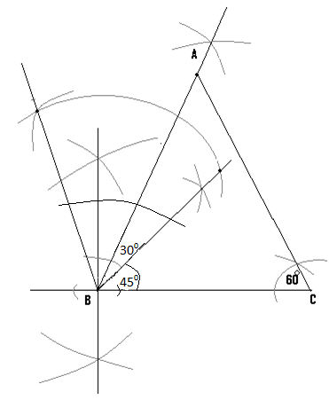

(b) – CD is parallel to AB.

- To locate the position of D, open the compass to the length of AB i.e. 6cm, and with the pin at C draw arc EF.

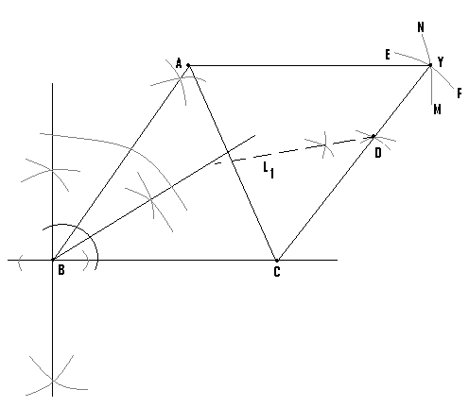

* The compass is now opened to the length BC i.e 5cm, and with the pin at A, draw arc MN to cut the first one at Y.
* Draw the first straight line to join C and Y, and the second one to join A and Y.
* Since CD is parallel to AB, the point D can lie any where on the line CY.
* But since D is also supposed to be equidistant from A and C, then it must also lie on the locus of points which are equidistant from A and C.
* We therefore construct this locus and let this be L1.
* At the point where L1 meets CY is the location of D.

N/B:

(C) Construct the bisector to AB and the point where It meets AB is E.

**Construction of angle 1050:**

* This is had by a combination of angle 600 and angle 450.

Example:

Construct angle 1050 at the point X.



Steps:

1. Construct angle 900 at X and bisect it to get angle 450.

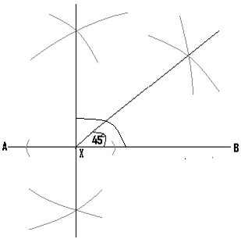

1. Construct angle 600

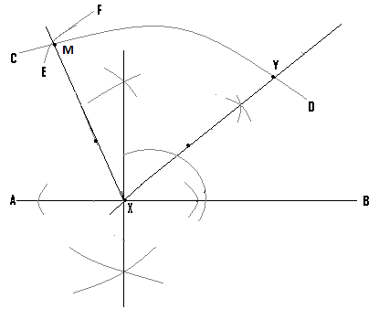

* With the pin at X, construct arc CD.
* With the same length and the pin at Y, construct arc EF.
* From point X draw a straight line which passes through M.

(Q3) Using a ruler and a pair of compasses only construct QRS such that <QRS = 1050, QR = 5cm and RS = 7cm.

Hint:

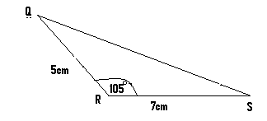

Soln:

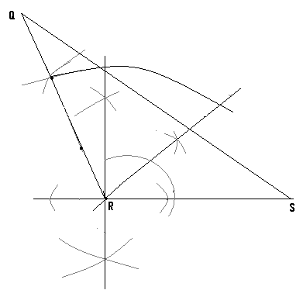

**Construction of a circumscribed circle:**

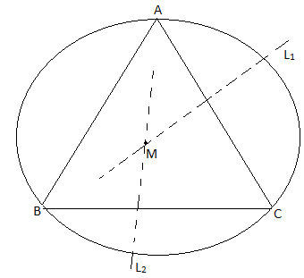

**-**The circle drawn passes through the points A,B and C which are the vertices of the triangle.

-A circumscribed circle is a circle, which passes through the three vertices of a given triangle.

-To construct such a circle, the perpendicular bisectors of two of the sides of a triangle, are drawn and their meeting point is noted.

-With the pin of the compass positioned at this meeting point, a circle can be drawn to pass through all the three vertices of the triangle.

-In the given diagram, L1 and L2 are the two bisectors whose meeting point is M.

-Therefore with the pin positioned at M, the circumscribed circle can be drawn.

**Construction of an inscribed circle:**

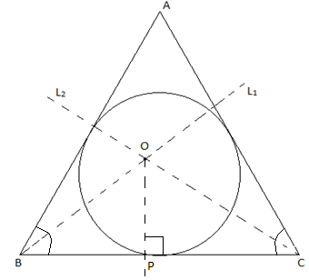

-An inscribed circle is one, which touches all the three sides of a given triangle.

-To construct such a circle and using the diagram just drawn as an example, L1 which is the bisector of <ABC and L2 which is the bisector <ACB are drawn, and let their meeting point be O.

-From the side BC, a perpendicular line (op) is then constructed.

- With the pin of the compass positioned at O and using the length OP, the inscribed circle can be drawn.

**NB:** As exercise, students are advised to attempt solving all the questions already solved, on their own.